AI-Enhanced Secure Application Access Management Using Zscaler Private Access (ZPA)

AI-Enhanced Secure Application Access Management Using Zscaler Private Access (ZPA)

List of Members :-

S no | Name | College Name | Contact Detail
01 | MADHAN KUMAR M | Sri Krishna Adithya College of Arts & Science | 23bscs128madhankumarm@skacas.ac.in
02 | KAVIYA R | Sri Krishna Adithya College of Arts & Science | 23bscs124kaviyar@skacas.ac.in
03 | ANJANA K S | Sri Krishna Adithya College of Arts & Science | 23bscs105anjanaks@skacas.ac.in
04 | YASHOTHA J | Sri Krishna Adithya College of Arts & Science | 23bscs165yashothaj@skacas.ac.in
05 | SHAIK NEEHA | Sri Krishna Adithya College of Arts & Science | 23bscs167shaikneeha@skacas.ac.in

INTRODUCTON:

In today’s digital environment, organizations rely heavily on cloud applications, remote work systems, and internet-based services. Employees often need to access organizational applications from different locations such as offices, homes, and mobile devices. This increased connectivity has also increased the risk of cyber threats, including unauthorized access, data breaches, and malware attacks. Therefore, ensuring secure access to applications has become an important requirement for modern organizations.

Traditional security methods such as Virtual Private Networks (VPNs) were widely used to allow employees to connect to internal networks. However, VPN-based systems provide broad network access once a user is authenticated, which may expose the entire network to potential threats. If an attacker gains access through a compromised account, they may move freely within the network. This limitation has led organizations to adopt more advanced security models such as the Zero Trust Architecture.

The Zero Trust security model operates on the principle of “never trust, always verify.” In this approach, every user and device requesting access to an application must be verified continuously, regardless of their location. Access is granted only to specific applications instead of the entire network. This significantly reduces the risk of unauthorized access and improves overall network security.

Zscaler Private Access (ZPA) is a cloud-based Zero Trust Network Access (ZTNA) solution developed by Zscaler. It allows users to securely access internal applications without exposing the network to the internet. ZPA connects authenticated users directly to the applications they are authorized to use, ensuring that other parts of the network remain hidden and protected. This application-specific access approach minimizes attack surfaces and enhances security.

In addition to secure access control, modern organizations are increasingly using Artificial Intelligence (AI) to strengthen cybersecurity systems. AI technologies can analyze large volumes of network data, identify unusual user behavior, and detect potential threats in real time. By integrating AI with access management systems, organizations can automate threat detection and improve their ability to respond quickly to security incidents.

In this project, an AI-enhanced approach is used to improve secure application access management through ZPA. AI techniques can monitor user access patterns, detect suspicious login attempts, and support administrators in enforcing security policies effectively. By combining AI-based monitoring with the Zero Trust capabilities of ZPA, the system can provide a more intelligent and secure access management solution.

The main goal of this project is to demonstrate how AI-enhanced security combined with Zscaler Private Access can help organizations protect their applications, ensure that only authorized users gain access, and reduce the risk of cyber threats. This approach provides a scalable and efficient security framework that supports modern digital workplaces and remote access environments.

ABSTRACT:

In the modern digital era, organizations increasingly rely on cloud services and remote work environments, which require secure and controlled access to internal applications. Traditional security solutions such as Virtual Private Networks (VPNs) often provide broad network access, which can increase the risk of unauthorized access and cyber attacks. To address these security challenges, organizations are adopting advanced security models such as Zero Trust Architecture.

This project focuses on implementing secure application access management using Zscaler Private Access (ZPA). ZPA is a cloud-based security solution developed by Zscaler that follows the Zero Trust model, allowing users to access only specific applications instead of the entire network. This approach helps protect sensitive organizational resources and reduces the risk of data breaches.

The proposed system also incorporates Artificial Intelligence (AI) techniques to enhance user protection and security monitoring. AI can analyze user behavior, detect unusual access patterns, and identify potential threats in real time. By integrating AI with ZPA, the system can improve threat detection, automate security policy enforcement, and provide better control over application access.

The objective of this project is to demonstrate how AI-enhanced security combined with ZPA can provide a secure, scalable, and efficient solution for managing application access in modern enterprise environments. This approach helps organizations strengthen their cybersecurity infrastructure while ensuring safe and reliable access to applications for authorized users.

Use Case Scenario:
Scenario 1: Finance Department Access to ERP System
A senior accountant in the finance department needs to access the corporate Enterprise Resource Planning (ERP) system to process monthly payroll. The user connects from a remote location using their company-managed laptop. Upon launching the ZPA Client Connector, they authenticate via Azure Active Directory with multi-factor authentication (MFA). AI continuously monitors user behavior for anomalies during the session. ZPA evaluates the user's identity, group membership (Finance_ERP_Users), device posture, and connection context. The policy engine determines the user is authorized and brokers a secure micro-tunnel to the ERP application only.
Output:
- User authenticated and authorized based on identity, group membership, and AI risk assessment
- Direct micro-tunnel established exclusively to ERP system
- All other internal applications and network segments remain invisible and inaccessible
- AI alerts if unusual actions (e.g., large bulk transactions) are detected

Scenario 2: Contractor Access to Specific Project Repository
An external software consultant requires access to a single Git repository on an internal server for a short-term project. The contractor is onboarded as a guest in the identity provider and assigned to the "Project_X_Contractors" group. Using ZPA, AI checks device compliance (firewall, OS patching) and user behavior patterns to detect anomalies. Access is time-bound (9 AM – 5 PM) and restricted to the Git repository.
Output:
- Role- and time-specific access enforced
- Contractor restricted to a single application
- Lateral movement to other systems blocked
- AI flags any abnormal repository activity, such as repeated failed login attempts

Scenario 3: Executive Access to Confidential M&A Documents
A company VP connects from abroad to access a SharePoint folder containing sensitive M&A documents. The company-managed tablet is compliant with security policies. AI detects the unusual geolocation and flags the session as high-risk. ZPA grants access with restrictions: read-only mode, download/print disabled, and session monitoring enabled. Security alerts are sent automatically.
Output:
- User authenticated with MFA and device compliant
- Read-only access with download/print restrictions
- AI risk score triggers real-time alerts to the security team
- Session monitored for unusual activities like bulk access attempts
Scenario 4: IT Support Technician Access to Internal Tools
An IT technician connects from home to assist an employee via ServiceNow and a remote desktop tool. ZPA verifies identity, IT group membership, and device compliance. AI monitors session activity for unusual support behavior or privilege escalation attempts. Direct micro-tunnels to required applications are created, ensuring least-privilege access.
Output:
- Technician authenticated and authorized based on identity, device, and context
- Micro-tunnels to ServiceNow and remote desktop established
- AI monitors for anomalous support actions
- Finance, HR, and development systems remain inaccessible
Scenario 5: Marketing Coordinator Access via Public Wi-Fi
A marketing coordinator accesses Salesforce from a coffee shop using a company smartphone. ZPA authenticates the user with MFA and checks device posture. AI flags the public Wi-Fi as high-risk and enforces browser isolation, preventing data from persisting on the device. The session is containerized to prevent unauthorized downloads or copy-paste actions.
Output:
- User authenticated with device compliance verified
- Access through secure AI-monitored browser isolation
- Data leakage prevented on public Wi-Fi
- AI continuously monitors for suspicious activity

Scenario 6: Research Team Access to AI-Model Repository
A research engineer needs access to an internal AI model repository from a home laptop. ZPA verifies group membership (Research_AI_Users) and device security. AI evaluates user access patterns and model download activity to prevent intellectual property theft. Access is restricted to the repository, and any unusual bulk download triggers an alert.
Output:
- Authorized access limited to the AI model repository
- AI detects abnormal download behavior and sends real-time alerts
- Micro-tunnel ensures no visibility to unrelated systems
- Least-privilege access maintained

Scenario 7: HR Department Access to Employee Records
An HR manager needs to review confidential employee records for performance appraisals. ZPA authenticates the user and evaluates device compliance. AI monitors user behavior for unusual activity like exporting large datasets or accessing unauthorized profiles. Access is granted only to HR applications.
Output:
- User authenticated and authorized based on group membership and device posture
- AI monitors session for unusual export or access patterns
- HR applications accessible; finance and development systems remain hidden
- Alerts generated on abnormal behavior

Scenario 8: Temporary Event Staff Access to Scheduling System
Temporary event staff require access to the company’s scheduling system for a one-week event. They use personal devices, so ZPA enforces device posture checks (antivirus, OS updates) and time-bound access policies. AI ensures the user does not attempt to access other internal applications or sensitive data.
Output:
- Time-limited access enforced based on role and device compliance
- AI monitors for any attempt to access other internal resources
- Micro-tunnel ensures secure connection only to scheduling system
- Temporary credentials automatically revoked after event

Stage – 1

Title:
AI-Enhanced Secure Application Access Management Using Zscaler Private Access (ZPA)

Overview:
In today's digital environment, organizations are rapidly adopting cloud technologies, remote work models, and distributed applications. Employees, partners, and contractors frequently access enterprise resources from multiple locations and devices. While this increased connectivity improves productivity and flexibility, it also introduces significant cybersecurity risks. Traditional network security models that rely on perimeter-based protection are no longer sufficient to protect modern enterprise infrastructure.
Historically, organizations relied on Virtual Private Network (VPN) technologies to enable remote access to corporate resources. VPN solutions authenticate the user and then grant access to the internal corporate network. Although this approach was effective when most applications were hosted within a centralized data center, it creates major security challenges in today's environment. Once connected through a VPN, users often gain broad network-level access, which can expose critical systems to potential attacks. If an attacker compromises a user account or device, they may be able to move laterally across the network, access sensitive data, and disrupt critical services.
To address these challenges, modern enterprises are transitioning toward Zero Trust security architecture. The Zero Trust model operates on the principle of “never trust, always verify.” In this approach, no user, device, or network connection is automatically trusted, even if it originates from inside the corporate network. Instead, every access request must be verified continuously based on multiple contextual factors such as user identity, device security posture, location, and application sensitivity.
This project focuses on implementing a secure application access management system enhanced with Artificial Intelligence (AI) using Zscaler’s Zscaler Private Access (ZPA) platform. ZPA is a cloud-delivered Zero Trust Network Access (ZTNA) solution designed to provide secure and direct connectivity between users and specific applications without exposing the corporate network. Unlike traditional VPN systems, ZPA does not place users on the internal network. Instead, it creates a service-initiated, application-specific connection that allows users to access only the applications they are authorized to use.
One of the key advantages of ZPA is its ability to make internal applications completely invisible to unauthorized users. Applications are never exposed to the public internet, and corporate IP addresses remain hidden. This architecture significantly reduces the attack surface and prevents common cyber threats such as port scanning, brute force attacks, and distributed denial-of-service (DDoS) attacks. By eliminating direct inbound connections to the internal network, the organization can ensure that only verified and authorized users gain access to enterprise applications.
In this project, Artificial Intelligence (AI) is integrated with ZPA to further strengthen access control and threat detection capabilities. AI technologies can analyze large volumes of user activity data, network traffic patterns, and device health metrics in real time. By continuously monitoring these parameters, AI can identify unusual behavior patterns that may indicate potential security risks. For example, if a user attempts to access sensitive applications from an unfamiliar location or downloads an unusually large amount of data, the system can automatically flag the activity and enforce additional security controls.
AI-driven security analysis enables the system to implement context-aware access policies. These policies consider multiple attributes before granting application access. These attributes include:
- User identity and authentication status
- User role or group membership within the organization
- Device posture, including antivirus status and operating system updates
- Geographic location of the user
- Risk level associated with the requested application
- Time of access and behavioral activity patterns

By analyzing these contextual parameters, the system can make intelligent access decisions that balance security and usability. For example, a trusted employee connecting from a company-managed device within the office network may be granted seamless access to business applications. However, the same user attempting to access sensitive data from a public network or unfamiliar device may be required to complete additional verification steps or may receive restricted access.
Another important objective of this project is to implement the principle of least privilege. Under this model, users and devices are granted only the minimum level of access required to perform their tasks. Instead of providing full network access, the system allows users to connect directly to specific applications through secure micro-tunnels. This approach prevents unauthorized access to other systems within the network and eliminates opportunities for lateral movement by attackers.
In addition to strengthening security, this approach also improves the overall user experience. Traditional VPN systems often require complex configurations and can introduce latency when users connect to internal networks. In contrast, ZPA uses a cloud-based architecture that automatically establishes optimized connections between users and applications. This results in faster application access, simplified connectivity, and reduced dependency on traditional network infrastructure.
From an operational perspective, adopting a cloud-based Zero Trust architecture also reduces the administrative burden on IT teams. Instead of managing multiple VPN gateways, firewall configurations, and network segmentation rules, administrators can define centralized access policies based on identity and context. These policies are automatically enforced across all applications and user sessions, improving consistency and simplifying security management.
The integration of AI with ZPA further enhances operational efficiency by enabling automated threat detection and response mechanisms. Security teams can receive real-time alerts when suspicious activity is detected, allowing them to respond quickly to potential threats. AI can also assist in identifying patterns of malicious behavior that might otherwise go unnoticed through manual monitoring processes.
Overall, the primary goal of this project is to demonstrate how AI-enhanced Zero Trust access management can provide a more secure, scalable, and intelligent solution for controlling application access in modern enterprise environments. By combining the capabilities of AI with the advanced security architecture of ZPA, the organization can significantly reduce its attack surface, protect sensitive applications, and ensure that only authorized users are able to access critical resources.
This approach represents a major step toward building a modern, intelligent cybersecurity framework that aligns with the evolving needs of digital enterprises. Through the implementation of AI-enhanced secure access management, organizations can strengthen their security posture while maintaining productivity, flexibility, and operational efficiency in an increasingly connected world.

List of Vulnerability:

S. No. | Vulnerability Name | CWE No.
1. | Improper Access Control | 284
2. | Insecure Temporary File | 377
3. | Cleartext Storage of Sensitive Information in a Cookie | 315
4. | Active Debug Code | 489
5. | Unimplemented or Unsupported Feature in UI | 447
6. | Reusing a Nonce, Key Pair in Encryption | 323
7. | Neutralization of Special Elements used in an OS Command ('OS Command Injection') | 78
8. | Cleartext Storage in a File or on Disk | 313
9. | Improper Certificate Validation | 1021
10. | webserver allows password auto-completion | 310
11. | Cross-site scripting (DOM-based XSS) | 79
12. | Improper Handling of Insufficient Privileges | 274

Report:
- Vulnerability name: Improper Access Control
CWE: 284
OWASP category: A01:2025 Broken Access Control
Description:
It occurs when a system fails to properly restrict access to resources from unauthorized users. Improper access control allows users to perform actions or access data beyond their intended permissions. This vulnerability happens when authentication or authorization mechanisms are not correctly implemented, allowing attackers to bypass security restrictions and gain unauthorized access to sensitive systems or information.

Business Impact:
Improper access control can allow attackers to access confidential data, modify system settings, or perform actions with higher privileges than intended. From an attacker's perspective, this vulnerability can be exploited to bypass security checks and gain unauthorized access to critical resources. If a privileged user account is compromised, the attacker may perform administrative operations, steal sensitive information, or disrupt system functionality, which can lead to data breaches, financial loss, and damage to the organization's reputation.

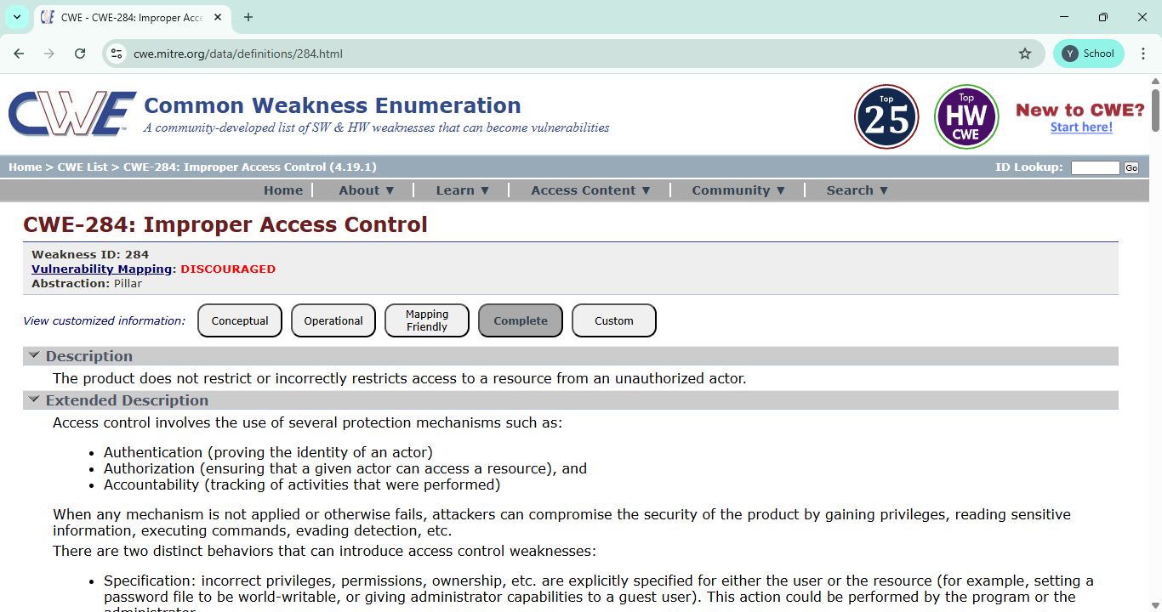

- Vulnerability name: Insecure Temporary File
CWE: 377
OWASP category: A01:2025 Broken Access Control

Description:
This vulnerability occurs when an application creates temporary files in an insecure location or without proper permissions. As a result, unauthorized users may access, modify, or delete these files, which can expose sensitive information or affect system functionality.

Business Impact:
This vulnerability can lead to data exposure, system manipulation, financial loss, and damage to the organization's reputation. It may also cause operational disruption and loss of customer trust.

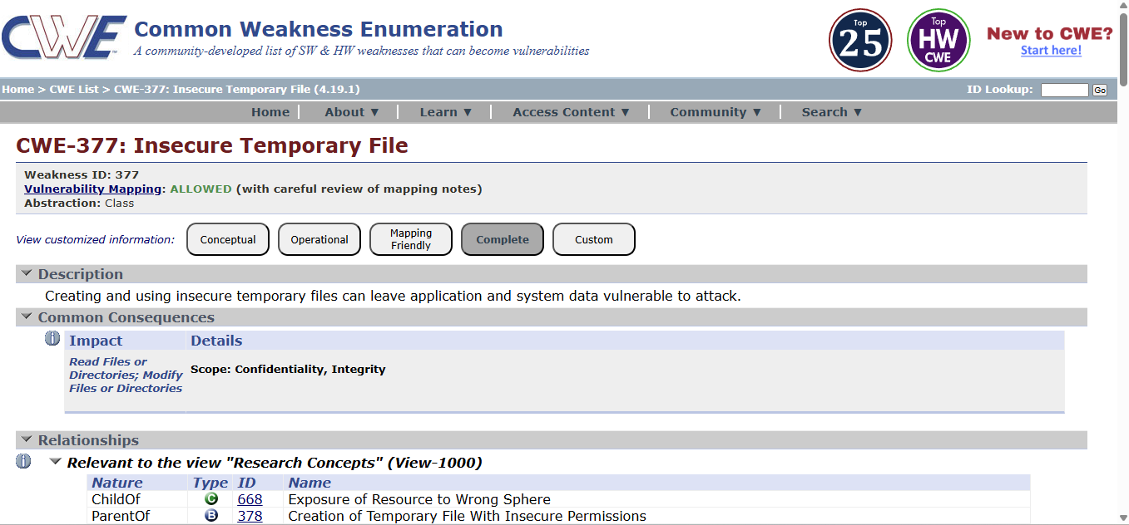

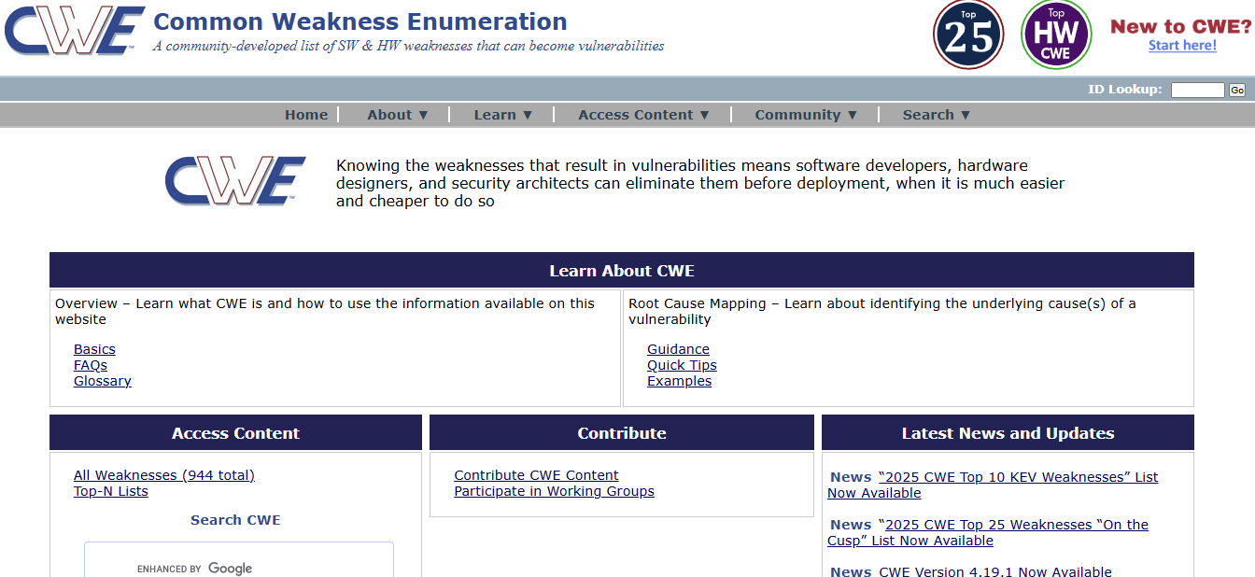

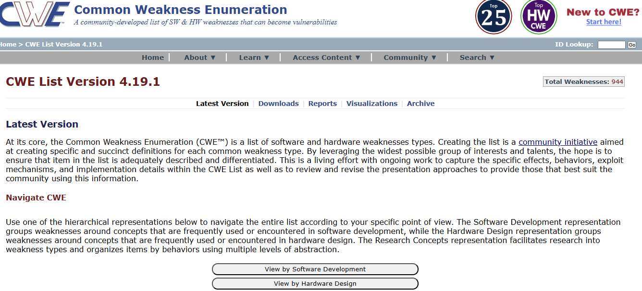

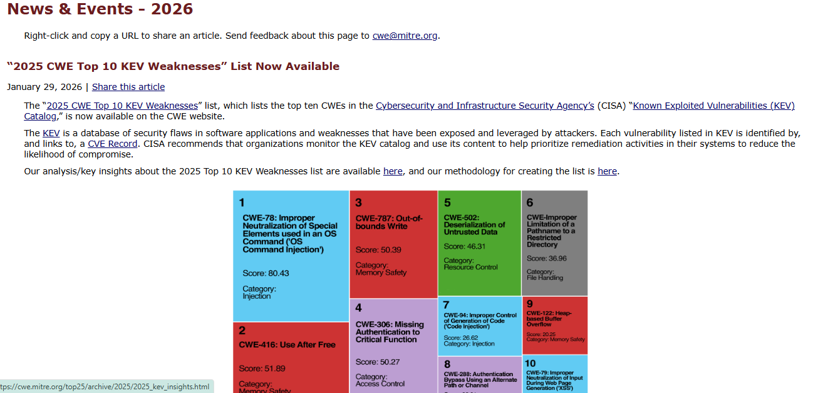

3.Vulnerability name: Cleartext Storage of Sensitive Information in a Cookie
CWE: 315
OWASP category:
A02:2025 Security
Misconfiguration

Description:
This vulnerability occurs when sensitive information such as user credentials, session IDs, or personal data is stored in cookies without proper encryption. Because cookies are stored on the user's browser, attackers may access or intercept this information if it is stored in cleartext.

Business Impact:
This vulnerability can lead to unauthorized access to user accounts, data leakage, and session hijacking. It may result in financial loss, privacy violations, and damage to the organization's reputation.

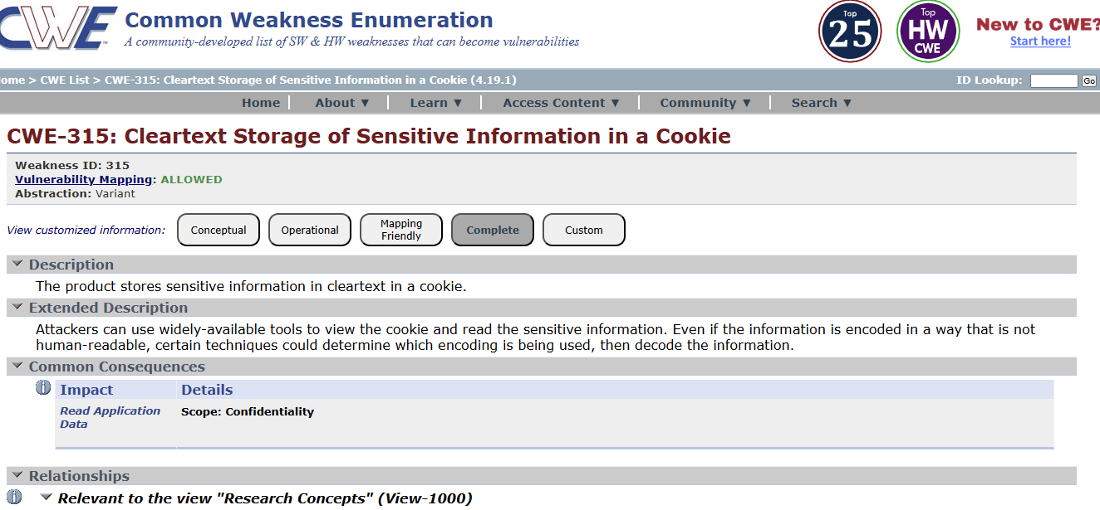

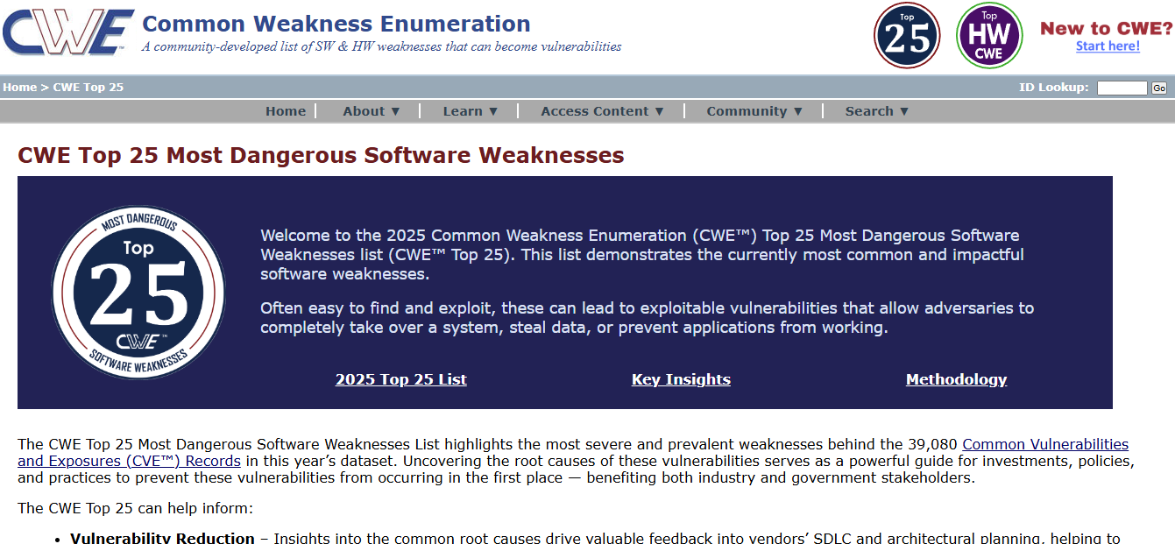

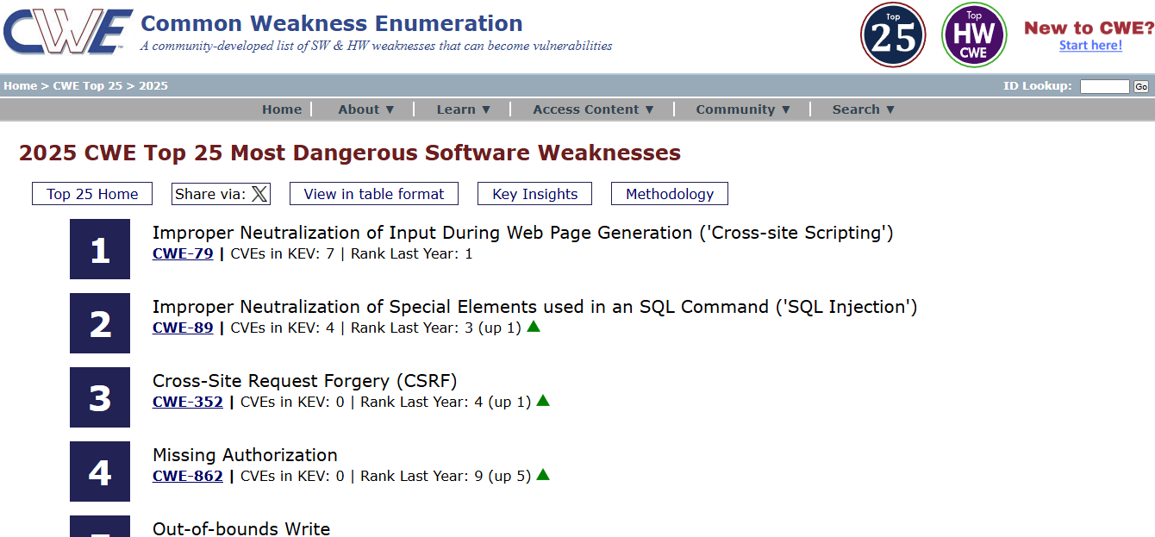

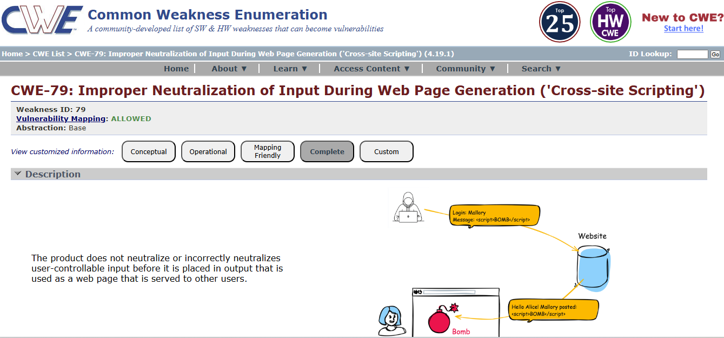

4. Vulnerability name: Active Debug Code
CWE: 489
OWASP category: A02:2025 Security Misconfiguration

Description:
This vulnerability occurs when debug or testing code is left active in the application after development. Debug code may expose internal system information, error messages, or hidden functionalities that attackers can use to understand the system and exploit vulnerabilities.
Business Impact:
Active debug code can expose sensitive system details and make it easier for attackers to identify security weaknesses. This may lead to unauthorized access, system manipulation, data breaches, and damage to the organization's reputation.

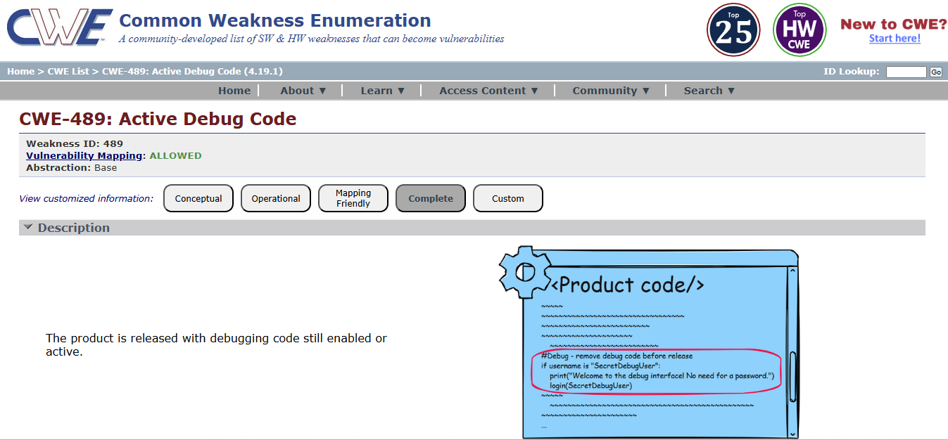

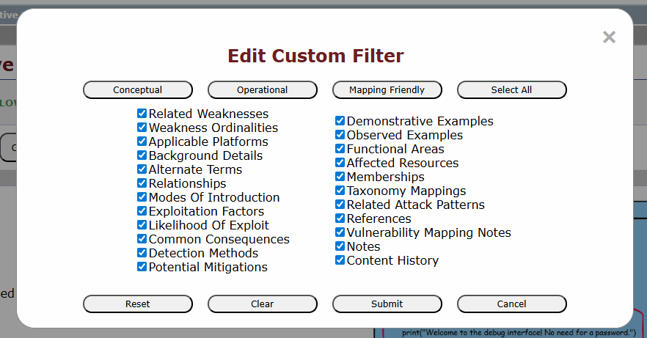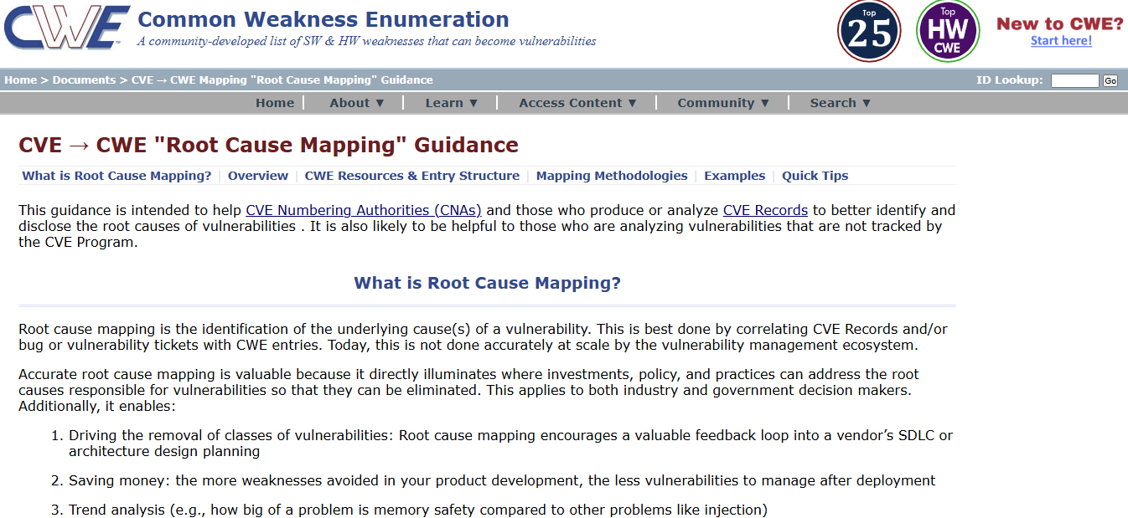

  - Vulnerability Name: Unimplemented or Unsupported Feature in UI
CWE: 447
OWASP Category: A03:2025 Software Supply Chain Failures

Description:
This vulnerability occurs when a user interface displays features or options that are not fully implemented or supported by the system. Such features may confuse users or create security risks if they trigger unexpected system behavior or expose incomplete functionality.

Business Impact:
Unimplemented or unsupported features can lead to user confusion, system errors, and potential security risks. Attackers may attempt to exploit these incomplete features to gain unauthorized access or disrupt system operations, which can affect the reliability and reputation of the organization.

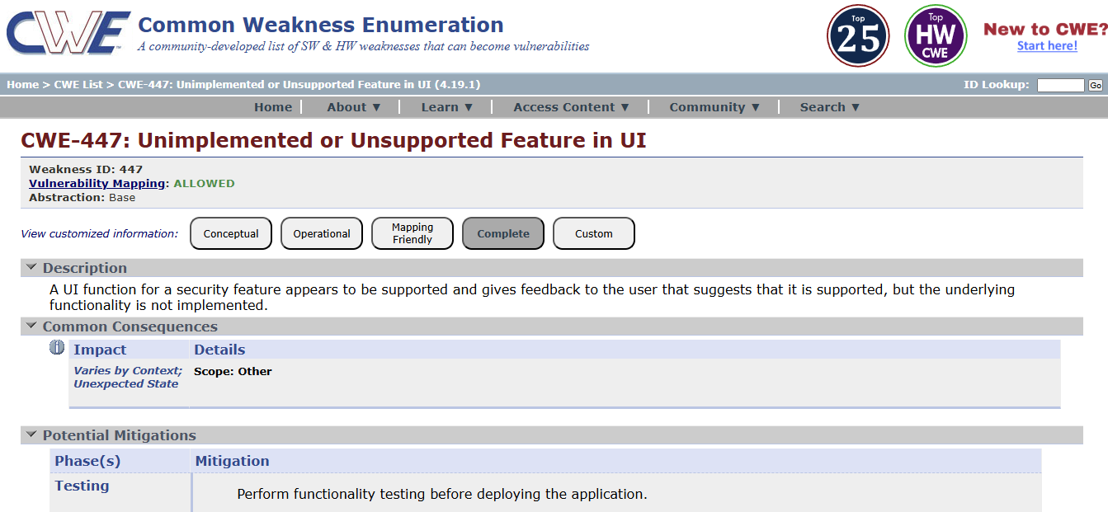

  - Vulnerability name: Reusing a Nonce, Key Pair in Encryption
CWE:323
OWASP Category: A04:2025 Cryptographic Failures
Description:
This vulnerability occurs when the same nonce (number used once) or cryptographic key pair is reused during encryption processes. Nonces and key pairs are meant to be unique for each encryption operation. Reusing them can weaken the security of the encryption algorithm and may allow attackers to analyze patterns and potentially recover sensitive data.
Business Impact:
Reusing nonces or key pairs can compromise the confidentiality of encrypted data. Attackers may decrypt sensitive information, leading to data breaches, financial loss, and damage to the organization's reputation.

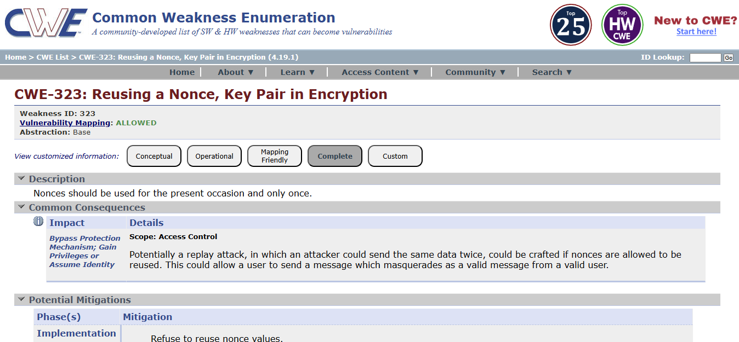

  - Vulnerability Name: Improper Neutralization of Special Elements used in an OS Command ('OS Command Injection')
CWS: 78
OWASP Category: A05:2025 Injection
Description:
This vulnerability occurs when an application executes operating system commands using user input without properly validating or sanitizing that input. Attackers can insert malicious commands into the input fields, which the system may execute on the server. This can allow attackers to run unauthorized system commands and gain control over the affected system.
BusinessImpact:
OS Command Injection can allow attackers to execute arbitrary commands on the server, leading to unauthorized access, data theft, or system compromise. This may cause operational disruption, financial loss, and damage to the organization's reputation.
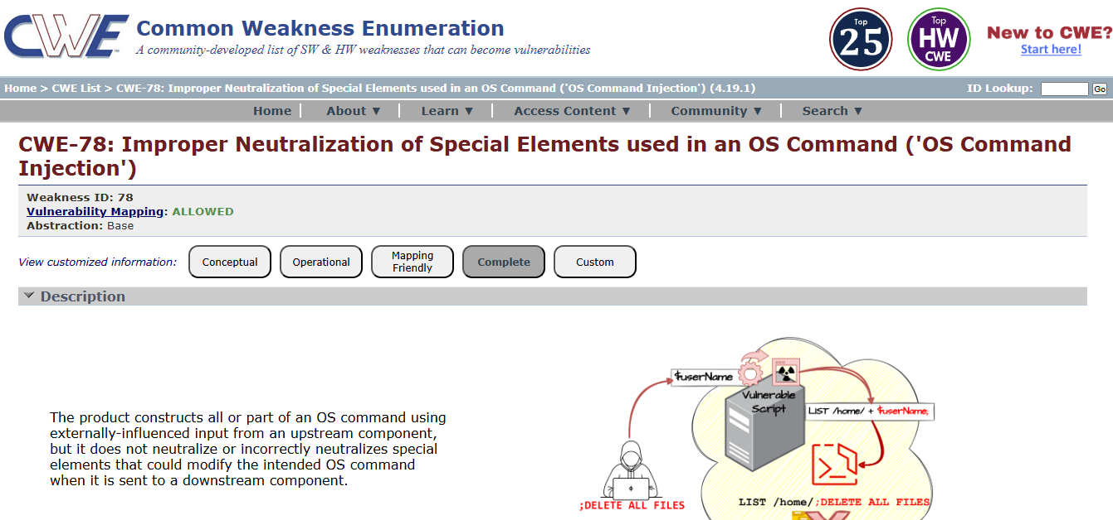

  - Vulnerability name: Cleartext Storage in a File or on Disk
CWE: 313
OWASP Category: A06:2025 Insecure Design

Description:
This vulnerability occurs when sensitive information such as passwords, personal data, or confidential system information is stored in files or on disk without encryption. If an attacker gains access to the system or storage location, they may easily read and misuse the stored data.

Business Impact:
Cleartext storage of sensitive data can lead to data breaches, unauthorized access, and exposure of confidential information. This may result in financial loss, legal issues, and damage to the organization’s reputation.
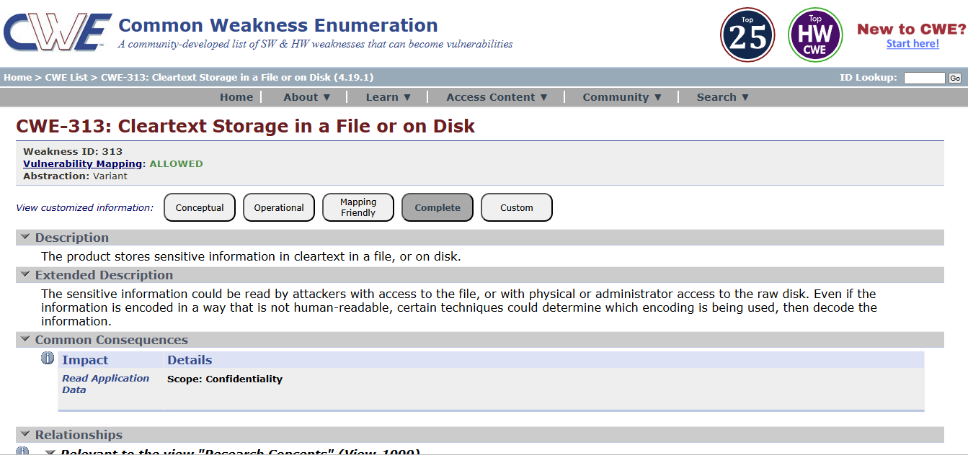

9. Vulnerability name: Improper Certificate Validation
CWE: 295
OWASP Category: A07:2025 Authentication Failures

Description:
This vulnerability occurs when an application fails to properly verify the validity of SSL/TLS certificates during secure communication. If certificate validation is not performed correctly, attackers may use fake or malicious certificates to intercept communication between the user and the server.

Business Impact:
Improper certificate validation can allow attackers to perform man-in-the-middle (MITM) attacks, leading to data interception, unauthorized access, and exposure of sensitive information. This can result in financial loss, security breaches, and damage to the organization’s reputation.

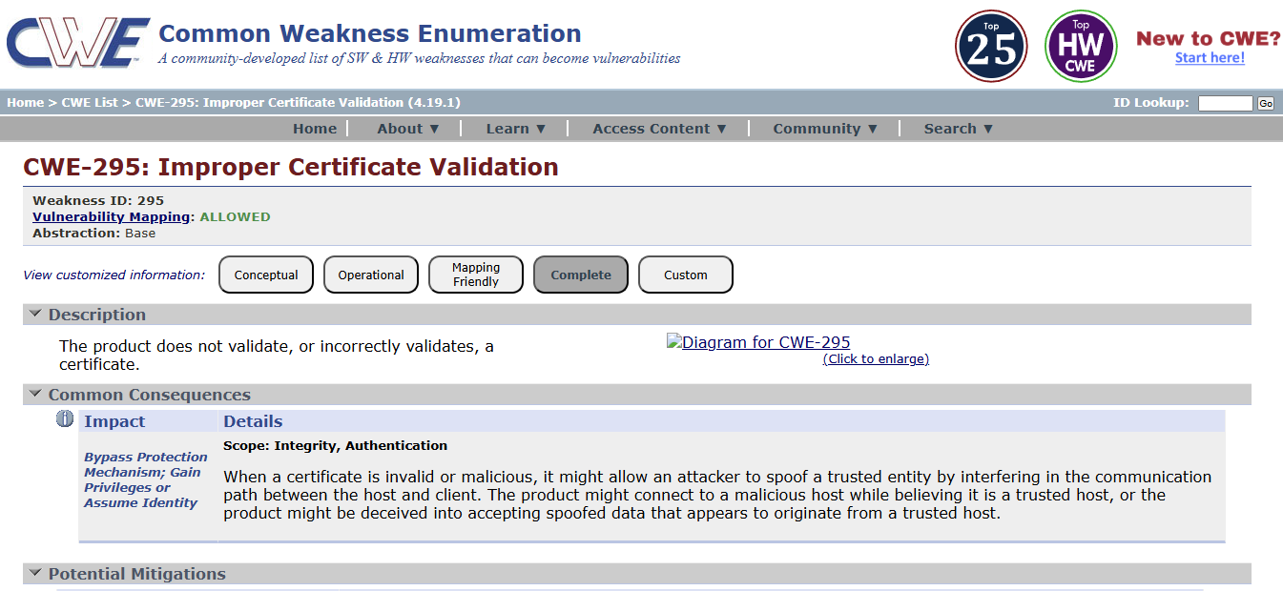

10. Vulnerability name: Deserialization of Untrusted Data
CWE: 502
OWASP Category: A08:2025 Software or Data Integrity Failures

Description:
This vulnerability occurs when an application deserializes data from untrusted or unknown sources without proper validation. Attackers may modify serialized data and send malicious input to the application. When the application processes this data, it may execute harmful code or perform unintended actions.

Business Impact:
Deserialization of untrusted data can allow attackers to execute arbitrary code, access sensitive information, or compromise the entire system. This can lead to data breaches, financial loss, and damage to the organization's reputation.

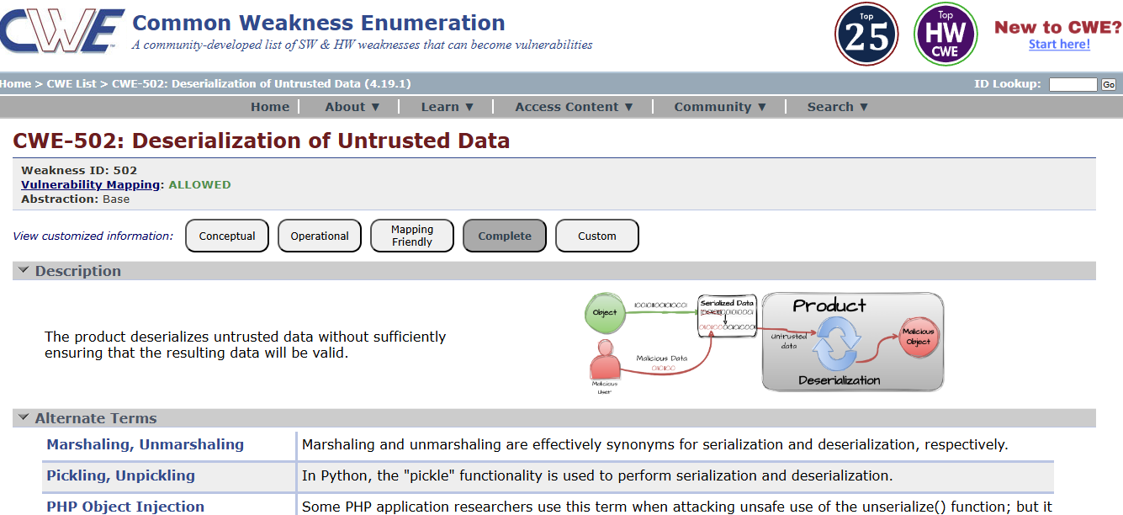

- Vulnerability name: Information Loss or Omission
CWE: 221
OWASP category: A09:2025 Security Logging & Alerting Failures

Description:
This vulnerability occurs when important information is lost, omitted, or not properly recorded during data processing, communication, or system operations. Missing or incomplete information may lead to incorrect system behavior, misunderstanding of data, or failure to properly track user actions and system events.

Business Impact:
Information loss or omission can cause inaccurate decision-making, operational errors, and difficulty in auditing system activities. It may also lead to compliance issues, reduced data reliability, and potential security risks for the organization.

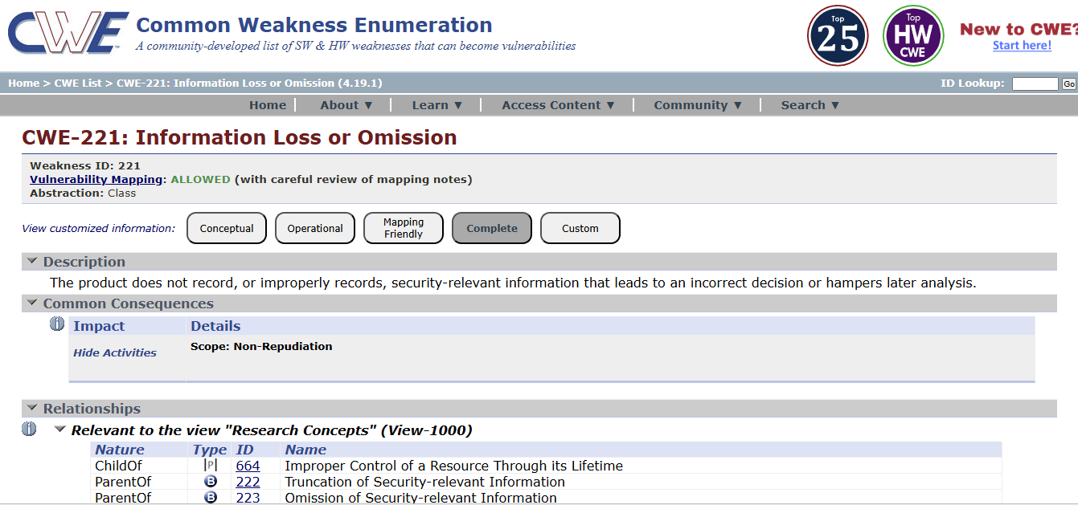

- Vulnerability name: Improper Handling of Insufficient Privileges
CWE: 274
OWASP category: A10:2025 Mishandling of Exceptional Conditions

Description:
This vulnerability occurs when an application does not properly handle situations where a user has insufficient privileges to perform an action. Instead of denying access, the system may allow the operation to proceed or may not correctly enforce permission checks. This can enable unauthorized users to access restricted resources or perform actions beyond their assigned permissions.

Business Impact:
Improper handling of insufficient privileges can lead to unauthorized access to sensitive data or system functions. Attackers may exploit this weakness to bypass security restrictions, which can result in data breaches, system misuse, and damage to the organization's reputation.

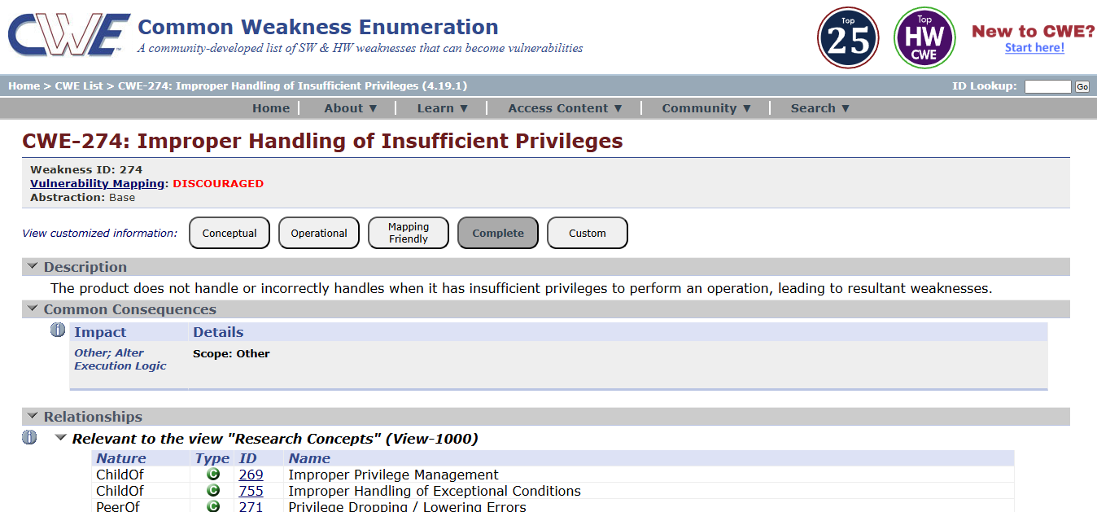

NESSUS SCAN REPORT:

ginandjuice.shop
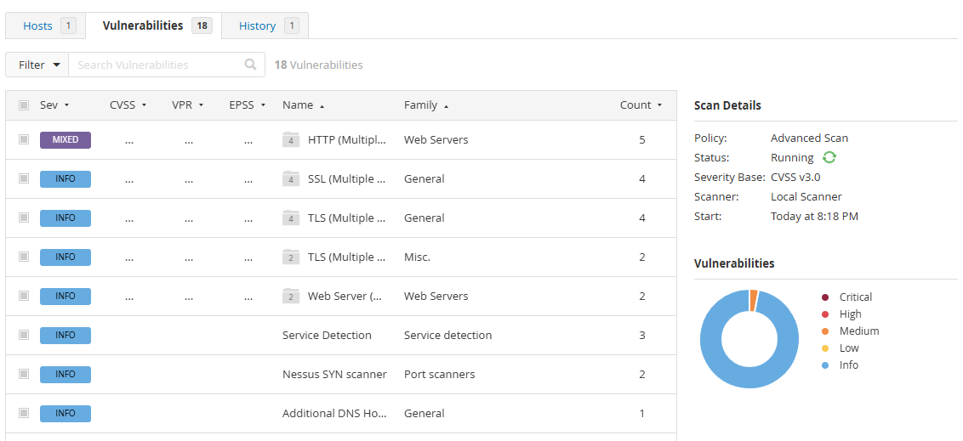
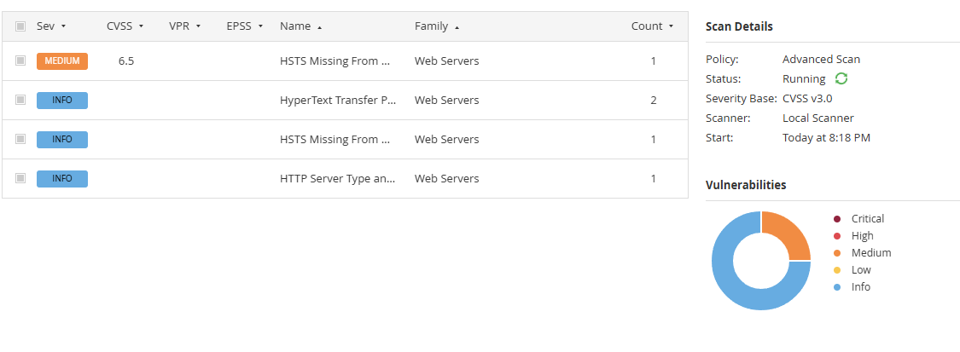

"With the Nessus scan report now at our disposal, we're equipped with critical data on the existing vulnerabilities and potential threats. This invaluable information will serve as a foundation for our project planning phase, as we chart the course to develop our AI-driven incident response platform with a well- informed strategy and timeline."

Stage – 2

Overview: -
An overview of AI-Enhanced Secure Application Access Management using Zscaler Private Access (ZPA) typically involves the following key steps and aspects:

1. Preparation:
Define Objectives:
Determine the scope and objectives of the secure access management system. Identify which applications, users, and network resources need secure access and what level of protection is required.
System Access:
Ensure that administrators have the necessary permissions and configurations to deploy ZPA and integrate AI-based security monitoring mechanisms.

2. Configuration
SetUpAccessPolicies:
Create security and access policies using ZPA to control how users connect to internal applications. AI models can assist in identifying unusual access patterns and enforcing adaptive security policies.
DefineProtectedApplications:
Specify the internal applications, servers, and services that need to be protected and accessed securely through the ZPA platform.

3. Secure Access Implementation
DeployZPAConnectors:
Install ZPA connectors within the internal network environment to establish a secure connection between users and applications without exposing the internal network.
AI-BasedMonitoring:
AI technologies analyze user behavior and access patterns to detect anomalies and potential threats in real time.

4. Threat Detection and Access Control
The system continuously monitors user activities and application access requests. AI-based analytics help detect suspicious behavior, unauthorized access attempts, and abnormal traffic patterns. Based on severity and risk level, the system can automatically enforce stricter access controls or block malicious activity.

5. Reporting
The system generates detailed reports on user access activities, detected threats, and security events. These reports include severity levels, recommended mitigation strategies, and evidence of suspicious activity. Reports can be exported in formats such as PDF, CSV, or dashboards for security monitoring.

6. Remediation
ReviewSecurityFindings:
Security teams analyze alerts and reports generated by the AI monitoring system and ZPA platform.
CorrectiveActions:
Take appropriate actions such as modifying access policies, blocking malicious users, updating security configurations, or strengthening authentication mechanisms.

7. Follow-Up and Continuous Monitoring
ContinuousMonitoring:
Regular monitoring ensures that the system detects new threats and unauthorized access attempts.
Integration:
Integrate the system with other security tools such as SIEM platforms or identity management systems to enhance the overall security posture.

8. Compliance Management
If compliance requirements are applicable, review security policies and access logs to ensure adherence to regulatory standards and organizational security policies.

9. Documentation
Maintain detailed records of system configurations, access logs, detected threats, and remediation actions. Proper documentation helps in auditing, compliance verification, and improving the system.

10. User Awareness and Training
Ensure that IT administrators and users understand how the secure access system works, including authentication procedures and security best practices to prevent unauthorized access.

Understanding the System:
AI-Enhanced Secure Application Access Management using Zscaler Private Access is a modern security approach designed to protect internal applications and network resources. It follows the Zero Trust security model, where users are granted access only after verification of identity, device posture, and security policies.

Key Features:
- Secure Application Access:
Users can securely access internal applications without exposing the internal network to the internet.
- Zero Trust Architecture:
Access is granted based on identity verification and security policies rather than traditional network trust.
- AI-Based Threat Detection:
Artificial Intelligence helps analyze access patterns and identify suspicious activities.
- Application Segmentation:
Applications are segmented and protected individually, reducing the attack surface.
- Policy-Based Access Control:
Administrators can define granular access policies based on user roles, devices, and location.
- Detailed Reporting:
The system provides comprehensive logs and reports for monitoring access activities and security events.
- Continuous Monitoring:
AI continuously monitors system behavior to detect and prevent potential threats.
- Integration Capabilities:
The system can integrate with identity providers, security tools, and monitoring platforms.

- Scalability:
ZPA supports large-scale enterprise environments and cloud-based applications.
- User-Friendly Management Interface:
Administrators can easily manage policies, monitor activity, and generate reports through an intuitive interface.

It's important to note that Nessus is a valuable tool for identifying vulnerabilities, but it doesn't fix these vulnerabilities itself. It's up to the organization's IT and security teams to take the necessary steps to remediate the identified issues to enhance their security.
List of vulnerability:

S. No | Vulnerability Name | Severity | Plugins
1. | Service Detection | Info | 22964
2. | Nessus SYN scanner | Info | 11219
3. | Host Fully Qualified Domain Name (FQDN) Resolution | Info | 12053
4. | Additional DNS Hostnames | Info | 46180
5. | HSTS Missing From HTTPS Server (RFC 6797) | Medium | 142960
6. | Device Type | Info | 54615
7. | Host Fully Qualified Domain Name (FQDN) Resolution | Info | 12053
8. | OS Fingerprints Detected | Info | 209654
9. | OS Identification | Info | 11936
10. | Remote Services Not Using Post-Quantum Ciphers | Info | 277650

Target Website: ginandjuice.shop
Target IP Address: 34.246.169.176

Report:
- VULNERABILITY NAME: Service Detection SEVERITY: Info
PLUGIN: 22964
PORT: 80 / tcp / www

Description:
Nessus was able to identify the remote service running on the target system by analyzing the service banner or the response generated when an HTTP request was sent. This means the server is revealing information about the service or software running on the system.

Solution:
• Disable unnecessary services that are not required on the server.
• Configure the web server to hide or limit banner information that reveals server details.
• Use security configurations to prevent detailed error messages from being displayed.
• Regularly update and patch the web server software to reduce the risk of vulnerabilities.
• Implement firewall rules to restrict unauthorized access to open ports and services.

Business Impact:
If attackers are able to identify the Fully Qualified Domain Name of a system, it may reveal useful information about the organization’s network structure and domain environment. This information can assist attackers in mapping the network and identifying potential targets for further attacks.

- VULNERABILITY NAME: Nessus SYN scanner
SEVERITY: Info
PLUGIN: 11219
PORT: 80 / tcp / www

Description:
The Nessus SYN scanner is used to identify open TCP ports on the target system by sending SYN packets and analyzing the responses. This type of scan helps determine which services are running on the system and whether those services are accessible from the network.

Solution:
• Disable or close unnecessary ports and services that are not required for the system’s operation.
• Configure firewall rules to restrict access to critical services and limit connections from unauthorized sources.
• Use intrusion detection or intrusion prevention systems (IDS/IPS) to monitor suspicious scanning activities.
• Regularly review open ports and network services to ensure that only essential services are exposed.
• Implement network segmentation to reduce the exposure of internal systems.

Business Impact:
Open ports and exposed services may provide attackers with information about the system’s network structure and running services. This information can be used by attackers to identify potential vulnerabilities and plan further attacks. If sensitive services are exposed, it could lead to unauthorized access, exploitation of known vulnerabilities, and compromise of system security.

- VULNERABILITY NAME: Host Fully Qualified Domain Name (FQDN) Resolution
SEVERITY: Info
PLUGIN: 12053
PORT: port 80/443

Description:

Nessus was able to determine the Fully Qualified Domain Name (FQDN) of the target host. The FQDN is the complete domain name that uniquely identifies a host within the Domain Name System (DNS). This information can help identify the system’s role in the network and the domain it belongs to.

Solution:

• Restrict unnecessary DNS information exposure to external users or networks.
• Configure DNS servers and network devices to limit domain name information disclosure.
• Implement firewall rules to control external access to internal network services.
• Ensure proper network segmentation to prevent attackers from gathering detailed system information.
• Regularly review system configurations to avoid revealing sensitive network details.
Business Impact:
If attackers are able to identify the Fully Qualified Domain Name of a system, it may reveal useful information about the organization’s network structure and domain environment. This information can assist attackers in mapping the network and identifying potential targets for further attacks. Although this issue is informational, it can still contribute to reconnaissance activities that may lead to more serious security threats.

- VULNERABILITY NAME:
Additional DNS Hostnames
SEVERITY: Info
PLUGIN: 46180
PORT: N/A

Description:
Nessus discovered additional DNS hostnames that resolve to the target system. These hostnames may represent alternative domain names or aliases associated with the same host. This information can reveal additional details about the network structure or services related to the target system.

Solution:
• Limit unnecessary DNS information exposure to external networks.
• Configure DNS servers to restrict public access to internal hostname records.
• Use firewall rules to control access to internal network services.
• Regularly review DNS configurations and remove unused or unnecessary hostnames.
• Implement network monitoring tools to detect suspicious DNS queries.

Business Impact:
If additional DNS hostnames are publicly accessible, attackers may gain insights into the organization’s network infrastructure and discover related systems or services. This information can assist attackers in reconnaissance activities, helping them identify potential targets for further attacks. Although this vulnerability is informational, it may increase the risk of targeted attacks if sensitive network details are exposed.

- VULNERABILITY NAME:
HSTS Missing From HTTPS Server (RFC 6797)
SEVERITY: Medium
PLUGIN: 142960
PORT: 443 / tcp / www

Description:
The remote HTTPS server does not send the HTTP Strict Transport Security (HSTS) header. HSTS is a security feature that forces browsers to communicate with the server only over secure HTTPS connections. Without HSTS, users may still connect to the website using insecure HTTP connections, which could expose them to man-in-the-middle attacks.

Solution:
• Configure the web server to enable the HTTP Strict Transport Security (HSTS) header.
• Ensure that all HTTP requests are automatically redirected to HTTPS.
• Use strong SSL/TLS configurations to secure communication between the client and the server.
• Regularly review web server security configurations to ensure secure transport protocols are enforced.
• Example header configuration:
Strict-Transport-Security: max-age=31536000; includeSubDomains

Business Impact:
If HSTS is not enabled, users may accidentally access the website over insecure HTTP connections. Attackers could intercept or manipulate the communication between the user and the server through man-in-the-middle attacks. This could lead to the exposure of sensitive information such as login credentials, personal data, or session cookies, potentially resulting in data breaches and
loss of user trust

- VULNERABILITY NAME: Device Type
SEVERITY: Info
PLUGIN: 54615
PORT: N/A

Description:
Nessus was able to determine the type of device running on the target system. The scanner identifies whether the host is a server, workstation, network device, printer, or another type of system based on its responses and detected services. This information helps in understanding the role of the system within the network.

Solution:
• Limit unnecessary information disclosure about system configuration and device details.
• Configure network security controls such as firewalls to restrict unauthorized scanning activities.
• Regularly review system and network configurations to ensure sensitive information is not publicly exposed.
• Implement network monitoring tools to detect suspicious reconnaissance or scanning attempts.

Business Impact:
If attackers can identify the type of device running on a system, it may help them understand the role of the system in the network and plan targeted attacks. For example, knowing that a system is a database server or network device may allow attackers to search for specific vulnerabilities related to that device. Although this issue is informational, it may assist attackers during the reconnaissance phase of an attack.

- VULNERABILITY NAME:
Host Fully Qualified Domain Name (FQDN) ResolutionForgery
SEVERITY: Info
PLUGIN: 12053
PORT: N/A

Description:
Nessus was able to determine the Fully Qualified Domain Name (FQDN) of the target host. The FQDN represents the complete domain name of a system in the Domain Name System (DNS), which uniquely identifies the host within a network. This information can reveal details about the system’s domain structure and its role within the organization’s network.

Solution:
• Restrict unnecessary exposure of DNS information to external networks.
• Configure DNS servers to limit access to internal domain information.
• Use firewall rules to control external access to internal systems and services.
• Regularly review DNS records and remove unused or unnecessary domain entries.
• Implement network monitoring tools to detect suspicious reconnaissance or scanning activities.

Business Impact:
If attackers are able to identify the Fully Qualified Domain Name of a system, it may provide useful information about the organization’s domain structure and network environment. This information can assist attackers during the reconnaissance phase of an attack, helping them map the network and identify potential targets. Although this vulnerability is informational, it may increase the risk of further attacks if sensitive network details are exposed.

- VULNERABILITY NAME: OS Fingerprints Detected
SEVERITY: Info
PLUGIN: 209654
PORT: N/A

Description:
Nessus detected operating system fingerprints on the target host. By analyzing network responses and system characteristics, the scanner was able to identify the probable operating system running on the device. This information may include details about the operating system type, version, or platform used by the host.

Solution:
• Limit unnecessary exposure of system information that may reveal operating system details.
• Configure firewalls and security devices to restrict unauthorized network scanning activities.
• Keep the operating system updated with the latest security patches and updates.
• Implement network monitoring tools to detect suspicious reconnaissance or fingerprinting attempts.
• Apply security hardening techniques to minimize system information disclosure.

Business Impact:
If attackers are able to identify the operating system running on a system, they may use this information to search for known vulnerabilities related to that specific OS version. This can help attackers plan targeted attacks against the system. Although this issue is informational, it may assist attackers during the reconnaissance phase and increase the likelihood of further exploitation attempts.
- VULNERABILITY NAME: OS Identification
SEVERITY: Info
PLUGIN: 11936
PORT: N/A

Description:

Nessus was able to identify the operating system running on the remote host. This is achieved by analyzing network responses, service banners, and system characteristics. The identified information may include the operating system type, platform, or version used by the target system.

Solution:

• Limit unnecessary disclosure of system and operating system information.
• Configure firewalls and network security devices to block unauthorized scanning attempts.
• Apply operating system security hardening techniques to reduce information exposure.
• Keep the operating system updated with the latest security patches and updates.
• Monitor network traffic to detect suspicious scanning or reconnaissance activities.

Business Impact:

If attackers can identify the operating system running on a system, they may use this information to search for known vulnerabilities associated with that OS version. This can help attackers plan targeted attacks or exploit specific weaknesses in the system. Although this vulnerability is informational, it may assist attackers in the reconnaissance phase of an attack.

- VULNERABILITY NAME:
Remote Services Not Using Post-Quantum Ciphers
SEVERITY: Info
PLUGIN: 277650
PORT: 443 / tcp / www

Description:
The remote service supports standard TLS encryption but does not use post-quantum cryptographic ciphers. Post-quantum cryptography refers to encryption algorithms designed to remain secure even against attacks from quantum computers. The absence of such ciphers does not currently pose an immediate risk, but it indicates that the system may not be prepared for future cryptographic threats.

Solution:
• Monitor developments in post-quantum cryptography standards and update cryptographic implementations when supported.
• Keep TLS configurations updated with modern and secure cipher suites.
• Regularly update server software and security libraries to support newer cryptographic algorithms.
• Follow security recommendations from standards organizations and vendors regarding quantum-resistant encryption.

Business Impact:
Currently, this issue has minimal immediate impact because most systems today still rely on traditional encryption algorithms. However, as quantum computing technology evolves, traditional cryptographic methods may become vulnerable to advanced attacks. Organizations that do not adopt future-ready encryption standards may face long-term risks related to data confidentiality and security.

Stage – 3

Title:
AI-Enhanced Secure Application Access Management Using Zscaler Private Access (ZPA)

Artificial Intelligence has become a transformative force in modern cybersecurity architectures, especially within Zero Trust environments where every access request must be continuously verified and validated. In traditional security models, policies are often static and rely heavily on predefined rules that may not adapt quickly to evolving threats. By incorporating AI-driven behavioral analytics into application access management systems like Zscaler Private Access (ZPA), organizations can move toward a more proactive and intelligent security model that dynamically detects anomalies and adjusts access controls in real time.

The implementation of AI-driven analytics begins with the continuous monitoring of user behavior and application access patterns. Every user interaction with enterprise applications generates a large volume of data, including login times, frequency of access, types of applications used, and the sequence of activities performed during a session. Machine learning algorithms analyze this behavioral data to build a baseline profile for each user. For instance, if an employee typically accesses internal finance applications during standard business hours from a corporate laptop, the AI system records this pattern as normal behavior. However, if the same account suddenly attempts to download large volumes of sensitive data at midnight from an unfamiliar device, the system recognizes this as a potential anomaly.

Once such anomalies are detected, the AI-enabled policy engine integrated with Zscaler Private Access can automatically trigger security actions. These responses may include temporarily blocking the connection, requiring additional authentication steps, limiting the user’s permissions, or alerting the security operations team. This dynamic response capability ensures that potential threats are mitigated instantly without waiting for manual intervention. In many cases, AI can detect suspicious behavior much earlier than traditional security tools, preventing attackers from escalating their privileges or accessing sensitive resources.

Another critical advantage of AI-enhanced access management is its ability to analyze large-scale network traffic patterns across the organization. Enterprises often operate thousands of applications and support remote employees connecting from various devices and locations. Monitoring such complex environments manually is extremely difficult. AI models can process massive datasets in real time and identify subtle indicators of compromise, such as unusual login sequences, rapid switching between multiple applications, or access attempts from geographically distant locations within a short period. These signals often indicate credential theft or automated attack attempts.

AI integration also improves the adaptive nature of Zero Trust policies. Instead of relying solely on predefined rules, the system continuously learns from new data and adjusts its risk assessment models accordingly. For example, if the AI engine observes that certain users frequently travel and access applications from different countries, it gradually adapts the risk model to reduce unnecessary access restrictions for those users while still maintaining strict controls against unknown or malicious activities. This intelligent adaptation reduces false positives and ensures that legitimate users can work efficiently without unnecessary interruptions.

Conclusion:

Stage 1: In conclusion, AI-Enhanced Secure Application Access Management using Zscaler Private Access (ZPA) plays a vital role in protecting modern enterprise applications in a highly distributed digital environment. As organizations increasingly adopt cloud services, remote work, and mobile access, traditional network security models that rely on perimeter-based protection are no longer sufficient. This approach integrates the principles of Zero Trust architecture with advanced Artificial Intelligence techniques to ensure that every access request is continuously verified based on multiple contextual factors such as user identity, device health, location, and behavioral patterns. By eliminating direct network exposure and establishing secure, application-level connections, ZPA significantly reduces the risk of unauthorized access and lateral movement within the network.

Stage 2: The implementation of AI-enhanced secure application access management using Zscaler Private Access (ZPA) provides important security insights into how enterprise applications are accessed and protected within an organization. By continuously monitoring user activity, device posture, location, and behavioral patterns, the system can identify potential risks and suspicious access attempts in real time. AI-driven analytics helps classify these activities based on risk level and highlights high-priority threats such as unusual login behavior, access from unknown devices, or attempts from unfamiliar locations that may indicate compromised credentials. To address these risks, the system recommends security actions such as enforcing multi-factor authentication, restricting access privileges, blocking suspicious sessions, or alerting administrators for further investigation. In addition, the platform supports compliance with modern cybersecurity standards and Zero Trust principles by enabling continuous monitoring, adaptive policy enforcement, and regular security updates Overall, this AI-based ZPA framework provides a clear understanding of application access security, helps organizations mitigate potential threats efficiently, and emphasizes the importance of ongoing monitoring and proactive security measures to maintain a strong and resilient digital infrastructure.

Stage 3: The implementation of AI-enhanced secure application access management using Zscaler Private Access (ZPA) represents a significant transition from traditional perimeter-based security to a modern, intelligent Zero Trust security architecture. By combining identity-based access controls with Artificial Intelligence–driven analytics, the system ensures that users are granted only the minimum level of access required to perform their tasks, thereby enforcing the principle of least privilege. This approach prevents unauthorized access and significantly reduces the risk of lateral movement within the network. Additionally, the use of AI enables continuous monitoring of user behavior, device health, and access patterns, allowing the system to detect anomalies and respond to potential threats in real time. The solution not only strengthens the organization’s overall cybersecurity posture but also ensures secure and seamless connectivity for employees accessing applications from remote or distributed environments. Moreover, eliminating reliance on traditional VPN-based access simplifies IT management, improves scalability, and provides deeper visibility into user–application interactions AI-integrated ZPA framework establishes a secure, flexible, and future-ready foundation for organizations undergoing digital transformation while ensuring robust protection of critical enterprise applications.

Future Scope:

Stage 1: The future scope of AI-enhanced secure application access management using Zscaler Private Access (ZPA) is highly promising as organizations continue to adopt cloud technologies, remote work models, and digital transformation initiatives. As enterprise applications move beyond traditional data centers into hybrid and multi-cloud environments, secure and intelligent access control mechanisms will become increasingly essential to protect sensitive organizational resources.
Here are some key aspects of its future scope:
- Increased Demand: As organizations increasingly adopt cloud computing, remote work environments, and digital services, the need for secure access to enterprise applications continues to grow. This increases the demand for advanced access management solutions that can securely connect users to applications without exposing the internal network.
- Advanced Technologies: The integration of modern technologies such as Artificial Intelligence, Machine Learning, and Internet of Things (IoT) will make access management systems more intelligent and adaptive. These technologies will help analyze user behavior, detect unusual activities, and automatically respond to potential security threats.
- Security Emphasis: With the rise in cyberattacks, ransomware incidents, and data breaches, organizations will place greater emphasis on implementing Zero Trust security models. Solutions like Zscaler Private Access will help ensure secure, identity-based access while protecting sensitive data and maintaining compliance with security standards and regulations.
- Mobile and Cross-Browser Testing: As mobile device usage and remote work continue to increase, organizations must ensure secure access to applications from various devices and locations. Future access management systems will provide stronger device posture checks and secure connectivity for users working from home, offices, or public networks.
- Performance Testing: As enterprises expand and application traffic grows, secure access solutions must handle large numbers of users without affecting performance. Future developments will focus on improving scalability, high availability, and faster application connectivity while maintaining strong security controls.

Stage 2: The future scope of AI-enhanced secure application access management for identifying security risks and preventing unauthorized access is highly promising due to the rapid expansion of digital platforms, cloud computing, and remote work environments. As organizations increasingly rely on secure online access to enterprise applications, the need for intelligent access control systems continues to grow. Solutions like Zscaler Private Access (ZPA) will play an important role in strengthening cybersecurity by implementing identity-based authentication, continuous monitoring, and least-privilege access policies. With the integration of Artificial Intelligence and machine learning, future access management systems will be capable of analyzing user behavior, detecting anomalies, and responding to suspicious activities in real time. Additionally, these systems will integrate with advanced security tools such as endpoint protection and security monitoring platforms to provide a comprehensive defense against cyber threats.
Here are some key aspects of its future scope:
- AI-Driven Testing: The integration of Artificial Intelligence (AI) and Machine Learning (ML) into secure access management systems will significantly improve the way security risks and unauthorized access attempts are detected. AI algorithms can analyze large volumes of user access data, behavioral patterns, and network activity to quickly identify anomalies that might be difficult for traditional security systems or human administrators to detect. In solutions like Zscaler Private Access (ZPA), AI-driven analytics will enhance real-time threat detection, automate risk assessment, and strengthen the overall Zero Trust security model.

- IoT and Mobile Device Security: With the rapid growth of Internet of Things (IoT) devices and the increasing use of mobile devices in corporate environments, secure application access management will need to expand to support these technologies. Future access management systems will focus on verifying device identity, monitoring device posture, and ensuring that only trusted IoT and mobile devices can securely access enterprise applications.
- Cloud and Multi-Cloud Security: As organizations continue to migrate applications to cloud and multi-cloud environments, secure access solutions will evolve to provide consistent protection across different platforms. Technologies like Zscaler Private Access will help enforce secure connectivity and identity-based access control for applications hosted across multiple cloud infrastructures.

- Container and Infrastructure Security: As containerization technologies such as Docker and Kubernetes become widely used for deploying applications, secure access systems will expand to monitor and protect containerized environments. This includes ensuring that access to container-based applications is properly authenticated and that security policies are consistently enforced across the infrastructure.

Stage 3: Future Scope of Context-Aware Access Control
The successful implementation of AI-Enhanced Secure Application Access Management using Zscaler Private Access (ZPA) establishes a strong foundation for building a more advanced and integrated enterprise security ecosystem. As organizations continue to evolve their cybersecurity strategies, several future enhancements can further strengthen the effectiveness of AI-driven, context-aware access control systems and improve overall protection of enterprise applications.
Here are some key aspects of its future scope:
- Integration with Secure Access Platforms:Future developments may involve integrating Zscaler Private Access with broader security platforms such as secure internet gateways and cloud security services to create a unified Secure Access Service Edge (SASE) framework. This integration will allow organizations to manage both internet traffic and private application access under a single security policy structure.
- Advanced Device Posture and Endpoint Security: Future systems will incorporate more advanced device posture verification mechanisms. Instead of basic compliance checks, access decisions will consider real-time security scores from endpoint protection tools, ensuring that devices showing signs of compromise are immediately restricted from accessing sensitive applications.
- Secure Access for Third-Party and Remote Users: Organizations increasingly rely on vendors, partners, and contractors who require temporary access to internal applications. Future access control frameworks will support time-limited, monitored, and highly controlled access for these external users, ensuring that they can only reach the specific resources required for their tasks.
- AI-Driven Anomaly Detection: Artificial Intelligence will play a larger role in analyzing user behavior and identifying unusual access patterns. Machine learning models can detect anomalies such as login attempts from unfamiliar locations, unusual access times, or abnormal application usage patterns, automatically triggering additional authentication or blocking suspicious activities.
- Cloud and Microservices Security: As enterprises deploy applications across multi-cloud environments and containerized infrastructures, secure access solutions will extend their protection to cloud workloads, microservices, and inter-service communication. This ensures that even internal service-to-service interactions remain encrypted, authenticated, and protected from unauthorized access.
- Automated Identity and Access Management: Future systems will integrate more deeply with identity management platforms to automate user access provisioning and deprovisioning. When employees change roles or leave the organization, their application permissions can be updated or revoked instantly, ensuring continuous enforcement of least-privilege access policies.
- Digital Experience Monitoring: Another future enhancement involves implementing digital experience monitoring tools to track user connectivity and application performance. These tools can help organizations identify network latency or connectivity issues early, ensuring that security measures do not negatively affect the productivity and experience of legitimate users.

Topics Explored:
- Zscaler
- Zero Trust Security Model
- Zscaler Private Access (ZPA)
- Malware Information Sharing Platform (MISP)
- Threat Intelligence
- Incident Response
- AI-Based Access Monitoring and Security Analytics

Tools Explored:
- Nessus
- OSWAP ZAP

